**JAVASCRIPT- DOC2**

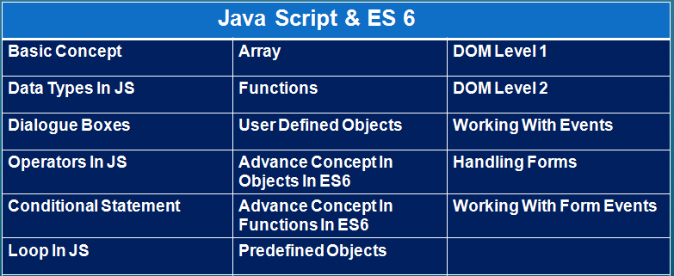

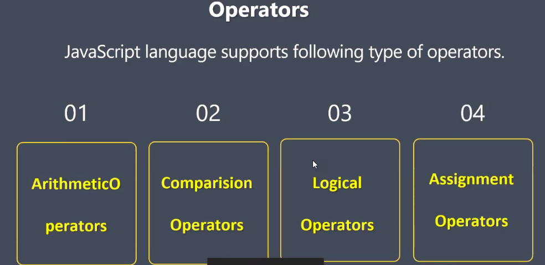

**Example:**

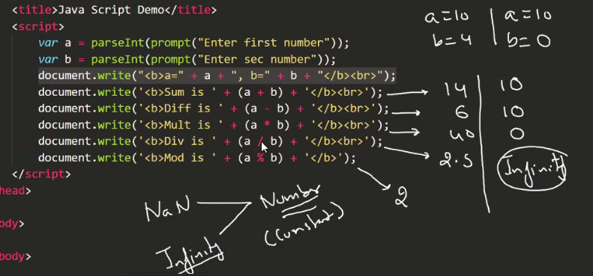

Max value which JS can hold is – 2^1023

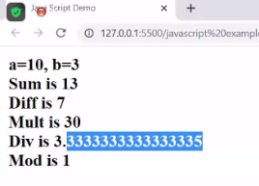

|  |  |
| --- | --- |
|  |  |

|  |  |
| --- | --- |
|  |  |

**Conditional operator**

|  |  |  |
| --- | --- | --- |
| **operator** | **What does?** | **Example, let x=5** |
|  | **It checks only value, not datatype** | **x==5 true**  **5==5 true**  **5==”5” true**  **5==5.0 true**  **x==8 false** |
|  | **It check value and type both. It is strict equal to** | **x===5 true**  **x===”5” false**  **5===5.0 true (b/c java me double and int sab no. h)** |
|  | **It check only value** | **x!=8 true**  **5!=8 true**  **5!=”5” false** |
|  | **It checkvalue and type both** | **5!==”5” true** |

**Examples-**

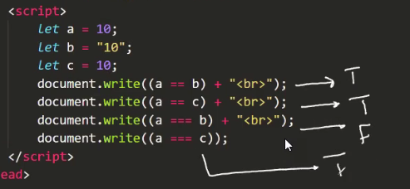

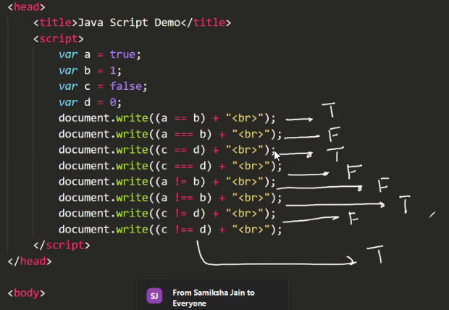

**Because-**

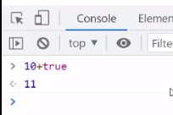

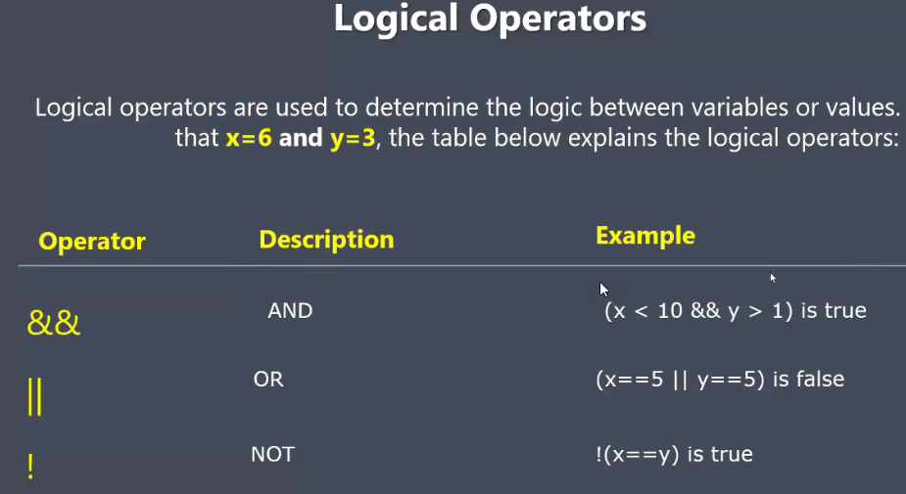

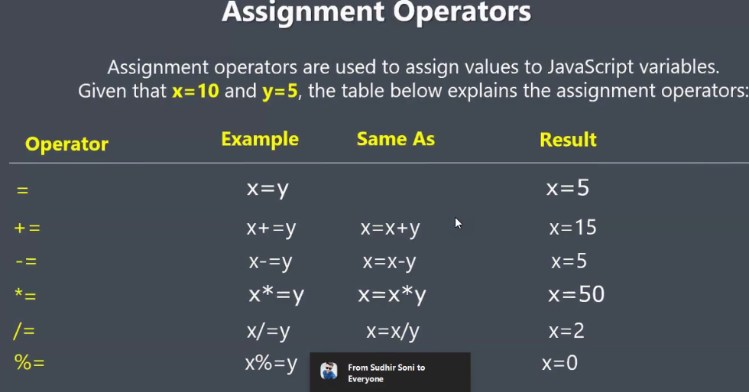

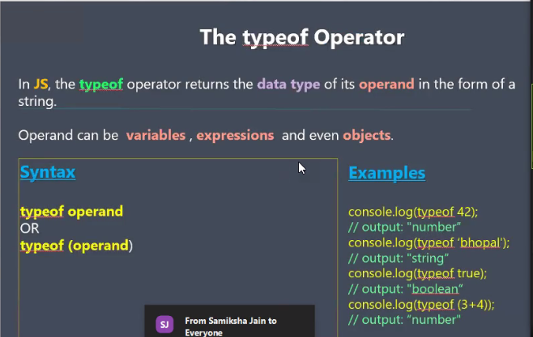

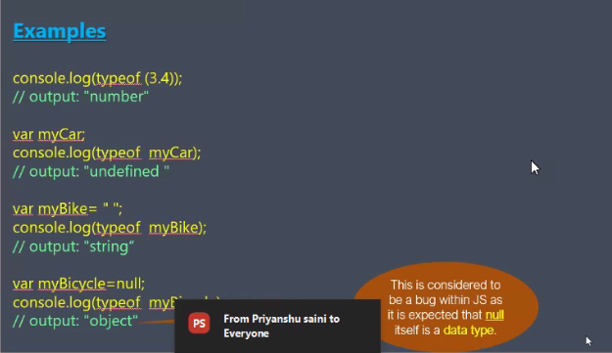

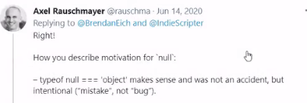

**typeof is a keyword and operator both, can not assign value to it**

**parseInt fun name , can assin value**

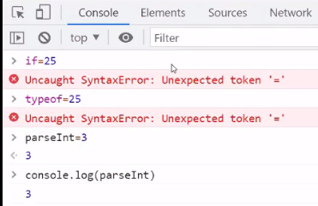

*******************************************************

|  |  |
| --- | --- |
| In java – explicit type conversion | (in java – Implicit type conversion) |
| If programmer doing some conversion | If javascript doing conversion  EX. parseInt()    10+true = 11 |

**Converting value into string-**

**1 way –**

let a=25

a+”” -🡪 becames string

**2 way –**

Global fun- string()

-----method of window obj, (direct call ho sakta h as like alert())

Method- toString()

---esko call krte time (.)aayega

Examples:

let a=25

* **typeof a**---number
* **let b=String(a)** [typeof a---number , typeof b ---string]
* **let c=a.toString()** [typeof a---number , typeof b ---string]

const a=25

(25).toString()—>25 is const so paranthesis will be required.

